*HARSH KASHYAP  
CSE 4*

*101917088*

[*hkashyap_be19@thapar.edu*](mailto:hkashyap_be19@thapar.edu)

A Practical activity Report submitted

for Practical Computing (UCS311)

**PRACTICAL COMPUTING**

**Evaluation Assignment 1**



Computer Science and Engineering

Patiala Campus

**2020**

Submitted to

Aashima Sharma

**__________________________________________**

**Question 1**

**Create a file named Rolllist in your home directory and Insert your roll number and one another roll number (matching pattern of your roll number) into it (Rolllistfile).**

* **Write a shell script that:**
* **accepts your roll no as command-line argument.**
* **matches the command line roll no with the Rolllist File.**
* **If script find roll no in Roll list file then Print the reverse of the roll number otherwise display the message “Roll number is not found in the file”**

**Write commands for every activity (1, 2 (a, b, c)) and attach screen shot.**

**Solution -**

**Creating RollList.txt**

1. **First of all, go to the home directory to create the file Rollist.**
2. **Then, create a file named Rollist.txt (namely, creating a text file), using the touch command.**
3. **Following this, use the cat command to add your and other few roll number in the file.**

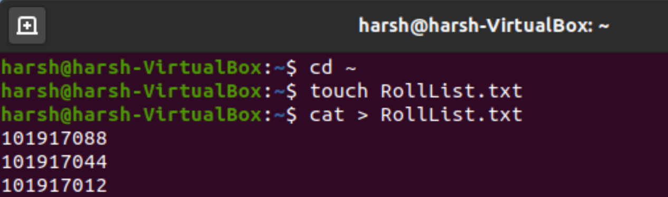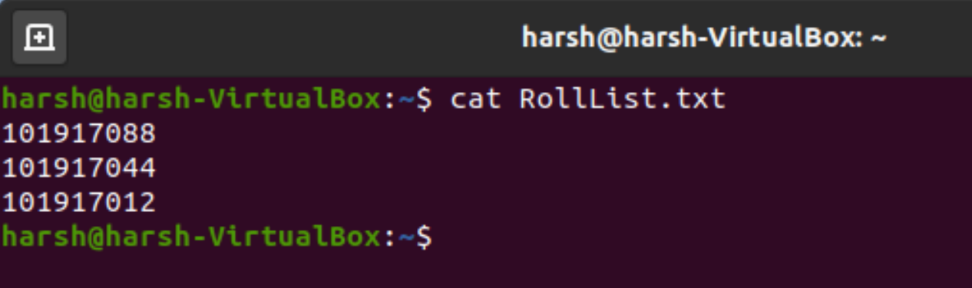

**Now, RollList file is created.**

**Now we will create a shell file, that will compare and match the Roll number witty file line argument.**

**Creating roll.sh**

1. **Create a shell script file.**
2. **Give command lines for better understanding**
3. **Take the input from the user as command-line argument and store it in a variable**
4. **There exist three conditions which needs to be checked:-**
   1. ***When no input is given as command line***

**Check whether there is a command-line argument using $#. If there is no input, display an appropriate message and return.**

* 1. ***When the input passed as an argument does not match any roll number in the file.***

**Display the message “Roll number is not found in the file”**

* 1. ***When the input passed as an argument matches any roll number in the file.***

**Print the roll number in reverse order.**

1. **Exit**

**Here are some snapshots of the following:-**

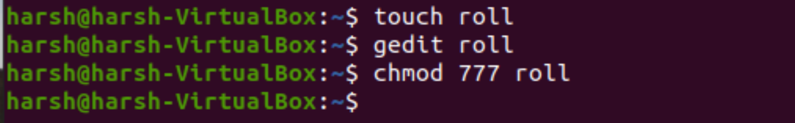

**The Shell Script of the program**

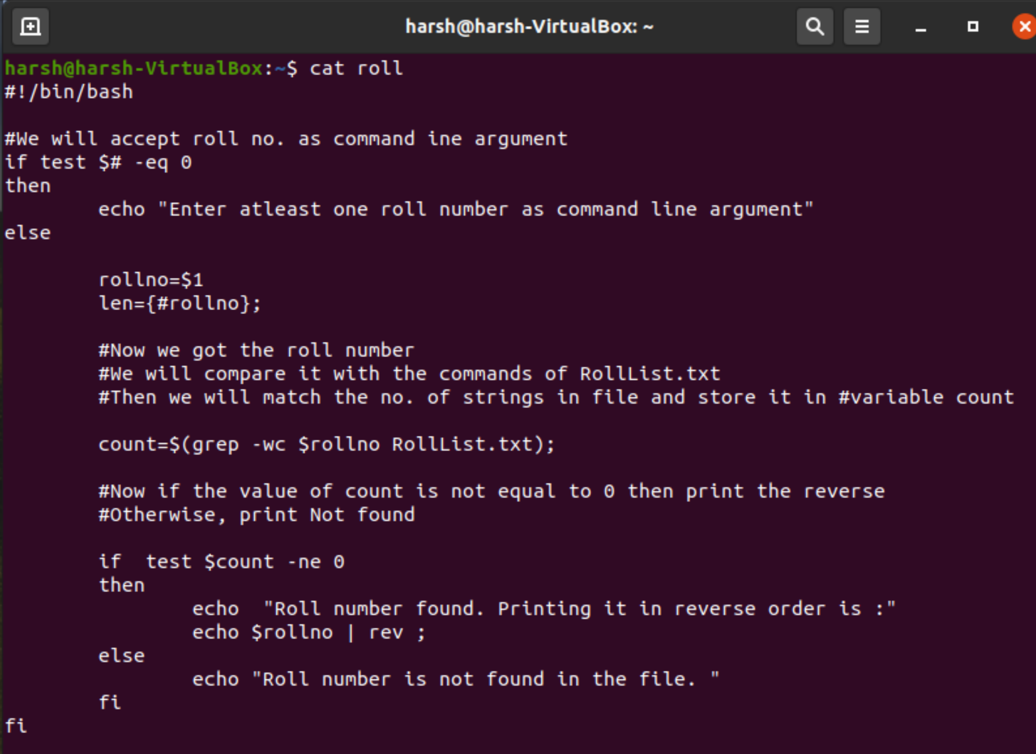

**OUTPUT (Various Command as parameters and their output)**

**Fully Functional and Fault Tolerant.**

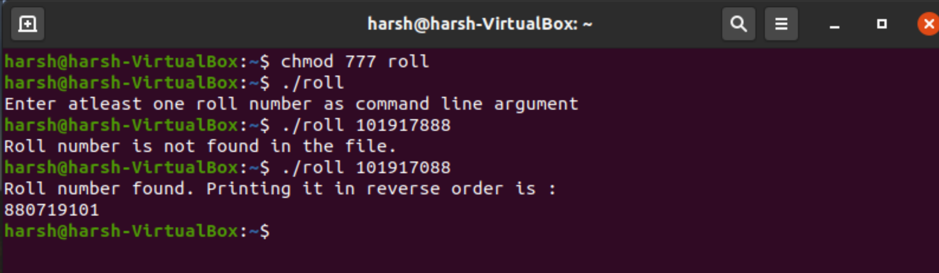

**__________________________________________**

**Question 2**

**Write a program to create the weekly schedule of your Practical computing class with menu driven option in shell script and save it as “PCSchedule”.**

**Hint: Menu –1. Monday, 2. Tuesday…………3. Saturday If option 1 (Monday) is selected, Display: Practical computing is scheduled at 8:00 am.**

**Save this script in a folder named “Server_share” on the server.**

**Further, access this file (script) from client folder named “Client_share” and execute it on the client’s terminal.**

**Solution -**

**In the Server System**

1. **Creating a folder name Server_share**
   1. **We will create this folder in /mnt**
   2. **We will log in as administrator using sudo -i**
   3. **First, we will visit mnt directory using command cd.**
   4. **We will create this folder using mkdir command**

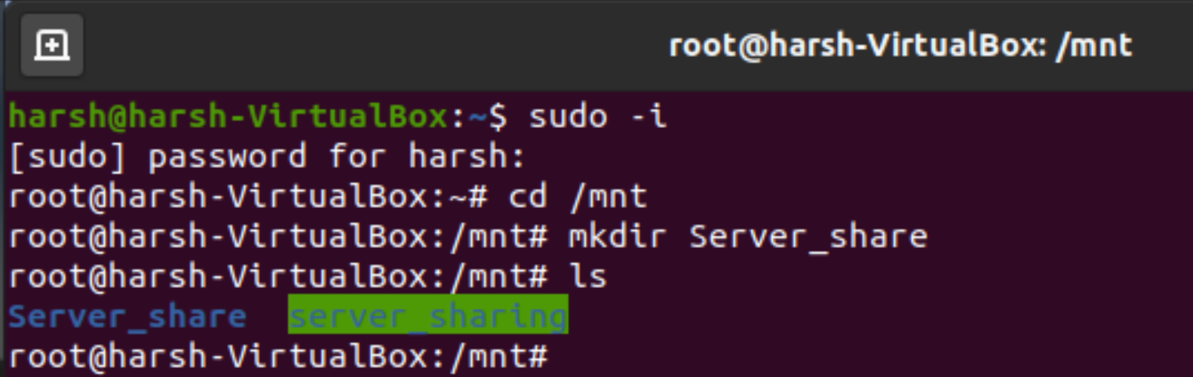

* 1. **Now we will create the shell script file named PCSchedule inside it**

1. **Working on the Shell Script PCSchedule.**
2. **Moving inside Server_share and creating shell file.**

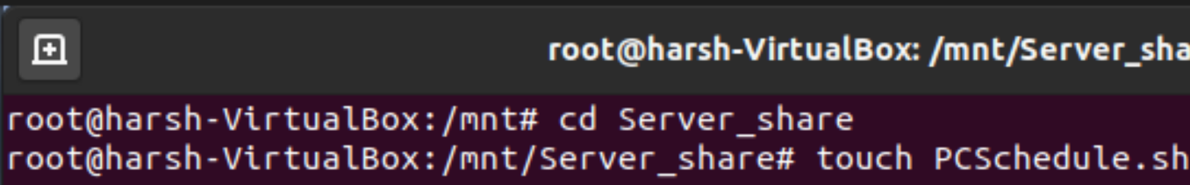

1. **Write a Shell script in nano editor.**

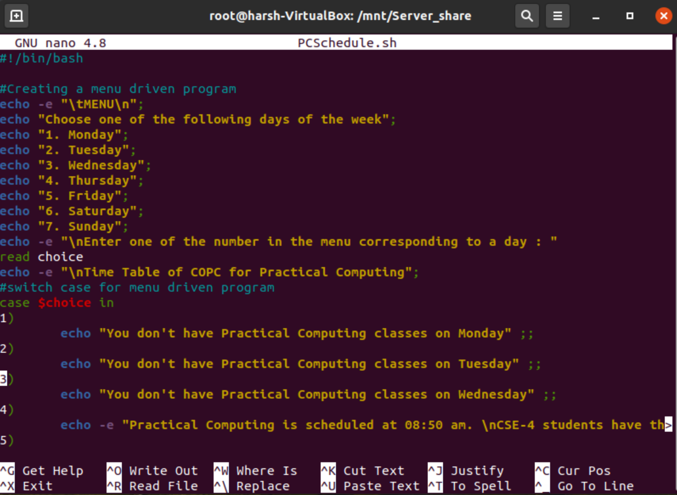

**(For demo purpose, showing how command was written using the editor)**

**The shell script using cat is displayed below.**

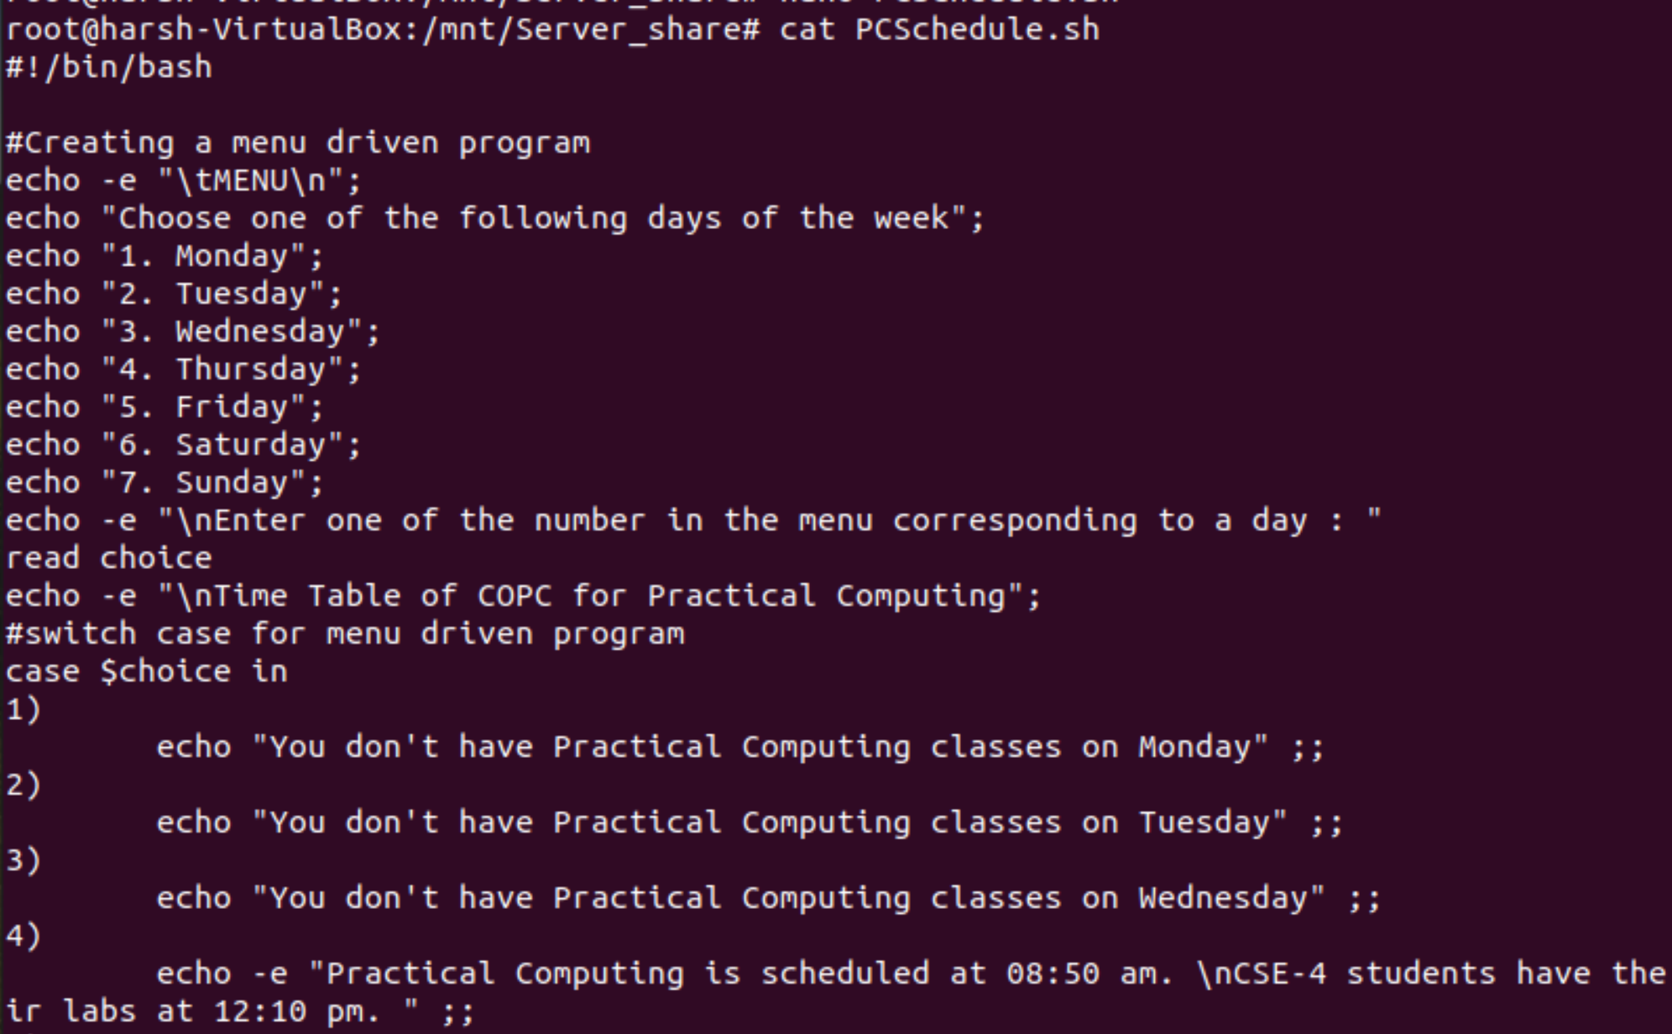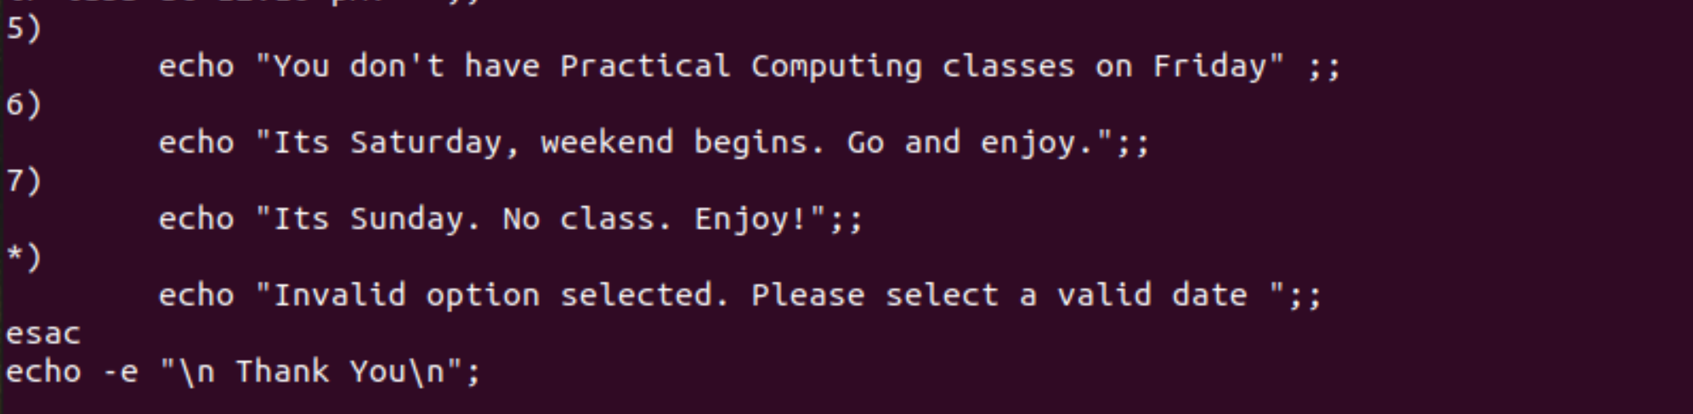

1. **Finally, give permission to execute using chmod.**

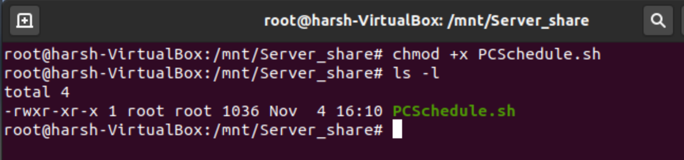

**3. Now create a NFS server to act as a bridge between Server and Client.**

**We have already installed NFS on both server and client systems**

**Doing further operation and attaching screenshots of the same.**

**SERVER SYSTEM**

* **Installing updates, and NFS server and doing the basics.**
* **Start the NFS service (if not already started)**

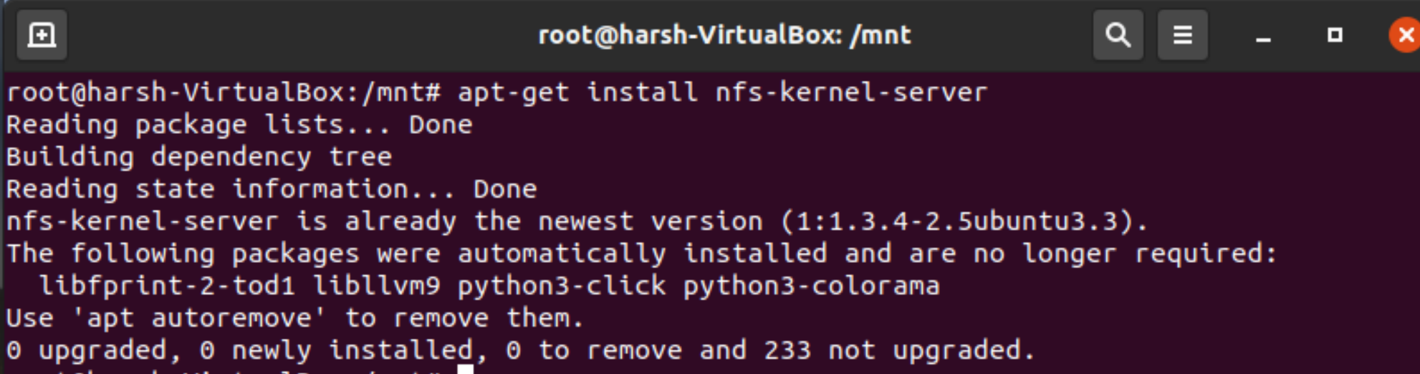

* **Changingthe *ow*nership and modifying the directory in which folder Server_share is stored. Change the owner/group of the directory to nobody/nogroup and give rwx to all.**

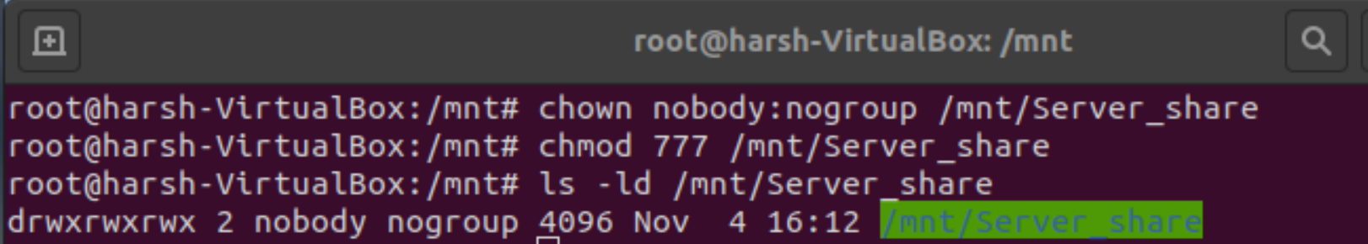

* **Using the nano editor on /etc/exports and making a bridge of the client on server.**
* **Go to the /etc/exports file to add the new entry to the file**

/server_share (rw,sync,no_root_squash)

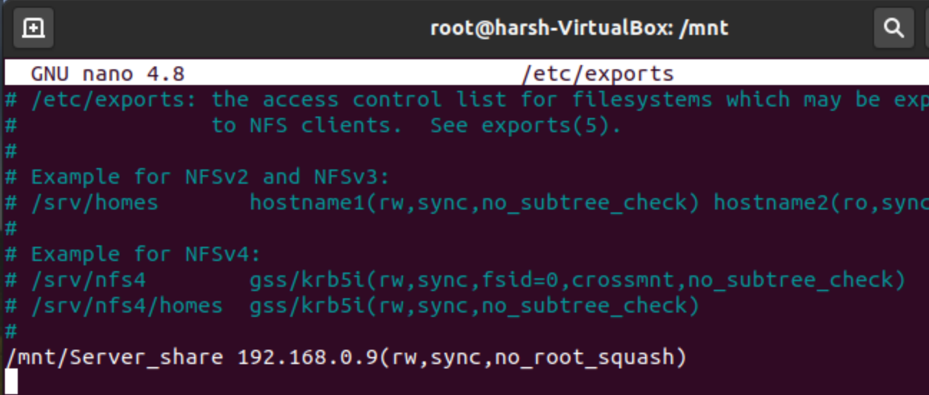

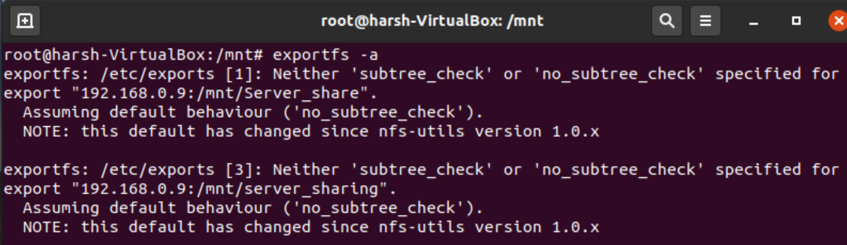

* **Checking if NFS server is active or not.**

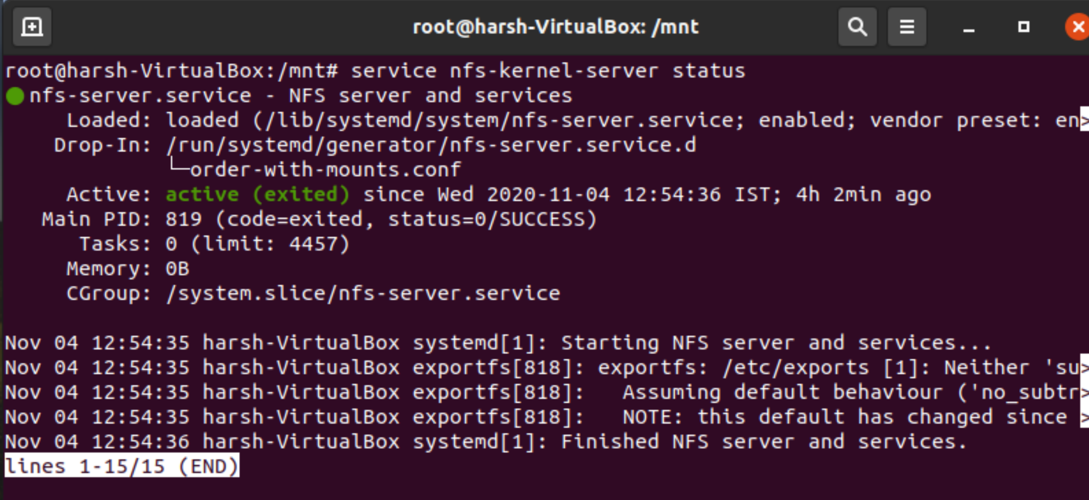

**CLIENT SYSTEM**

* **Installing the update, and NFS common and doing the basics.**

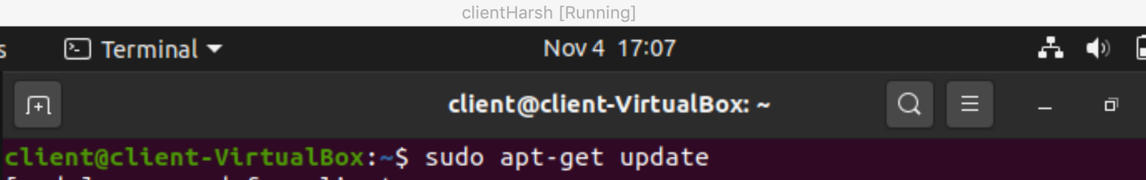

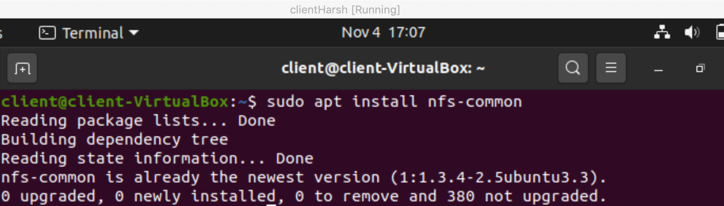

* **Checking status of the server and using showmount with IP address to view the server file on Client system.**

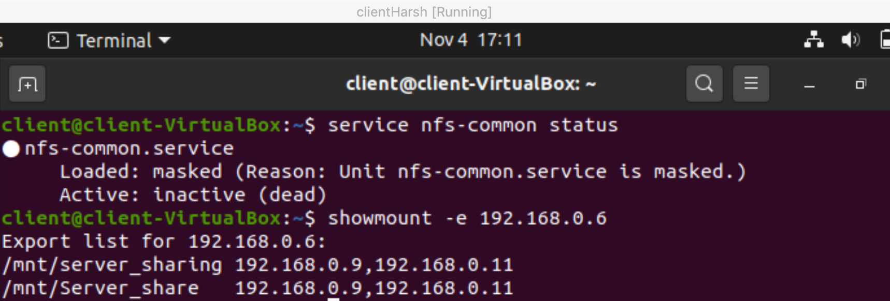

* **Login as root and make a directory to connect to the server “Server_share”**

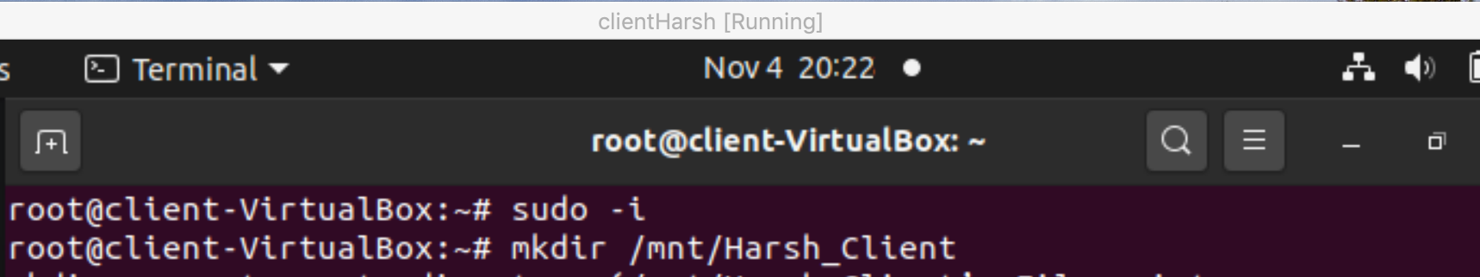

* **Now use mount with IP address of server to attach the Client directory with server directory. We can see the file PCSchedule when we use ls command in Client System.**
* **Now you can access the file on the client machine by going to the directory and executing the file**

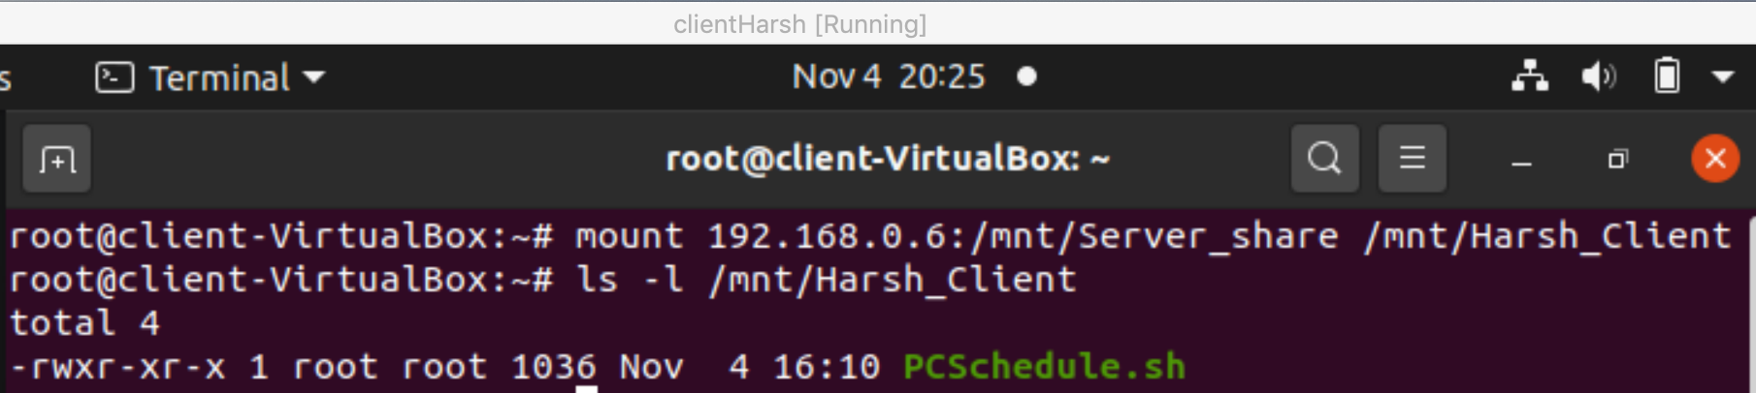

**4. Executing PCSchedule on client System**

**After this, you will see the same output window as shown above for the shell script PCSchedule.sh**

**OUTPUT**

1. **Fully Functional**

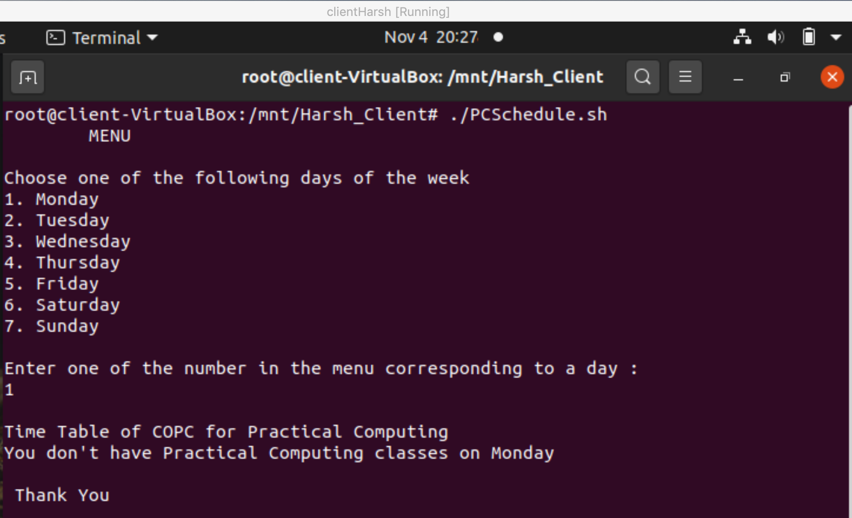

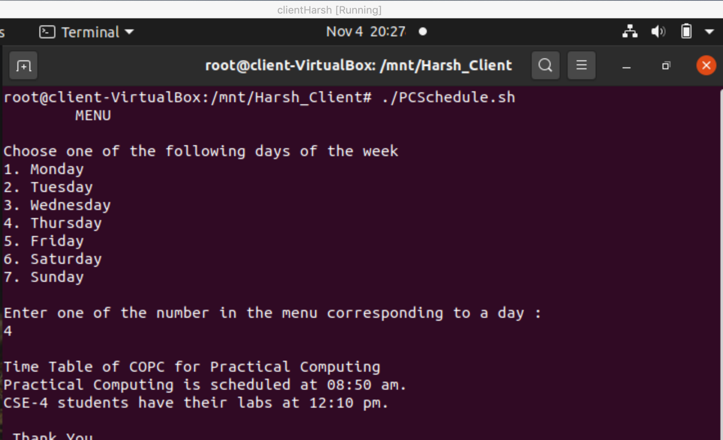

1. **Fault Tolerant**

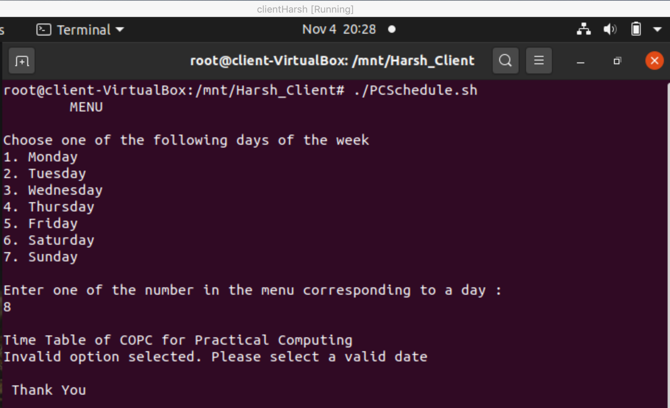

**__________________________________________**

**Question 3**

**Take a name as an input from the user.**

**Write a shell script to check whether there is a directory or file with that name. eIf any of this exists then print “This is a directory” or “This is a file” respectively, otherwise give three options to the user for creating a new directory or file with that input name or do nothing. Create a directory or file or do nothing as per the selected option by user.**

**Solution -**

**Creating a Shell File for the Same and sharing the source code.**

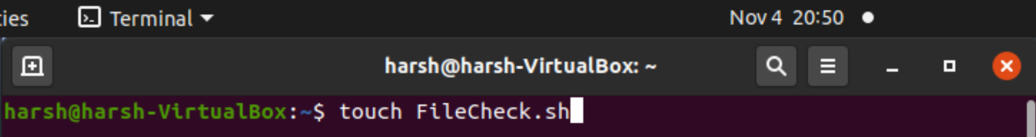

**Making the file executable.**

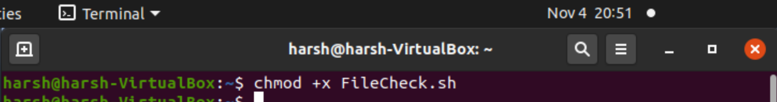

**Source Code**

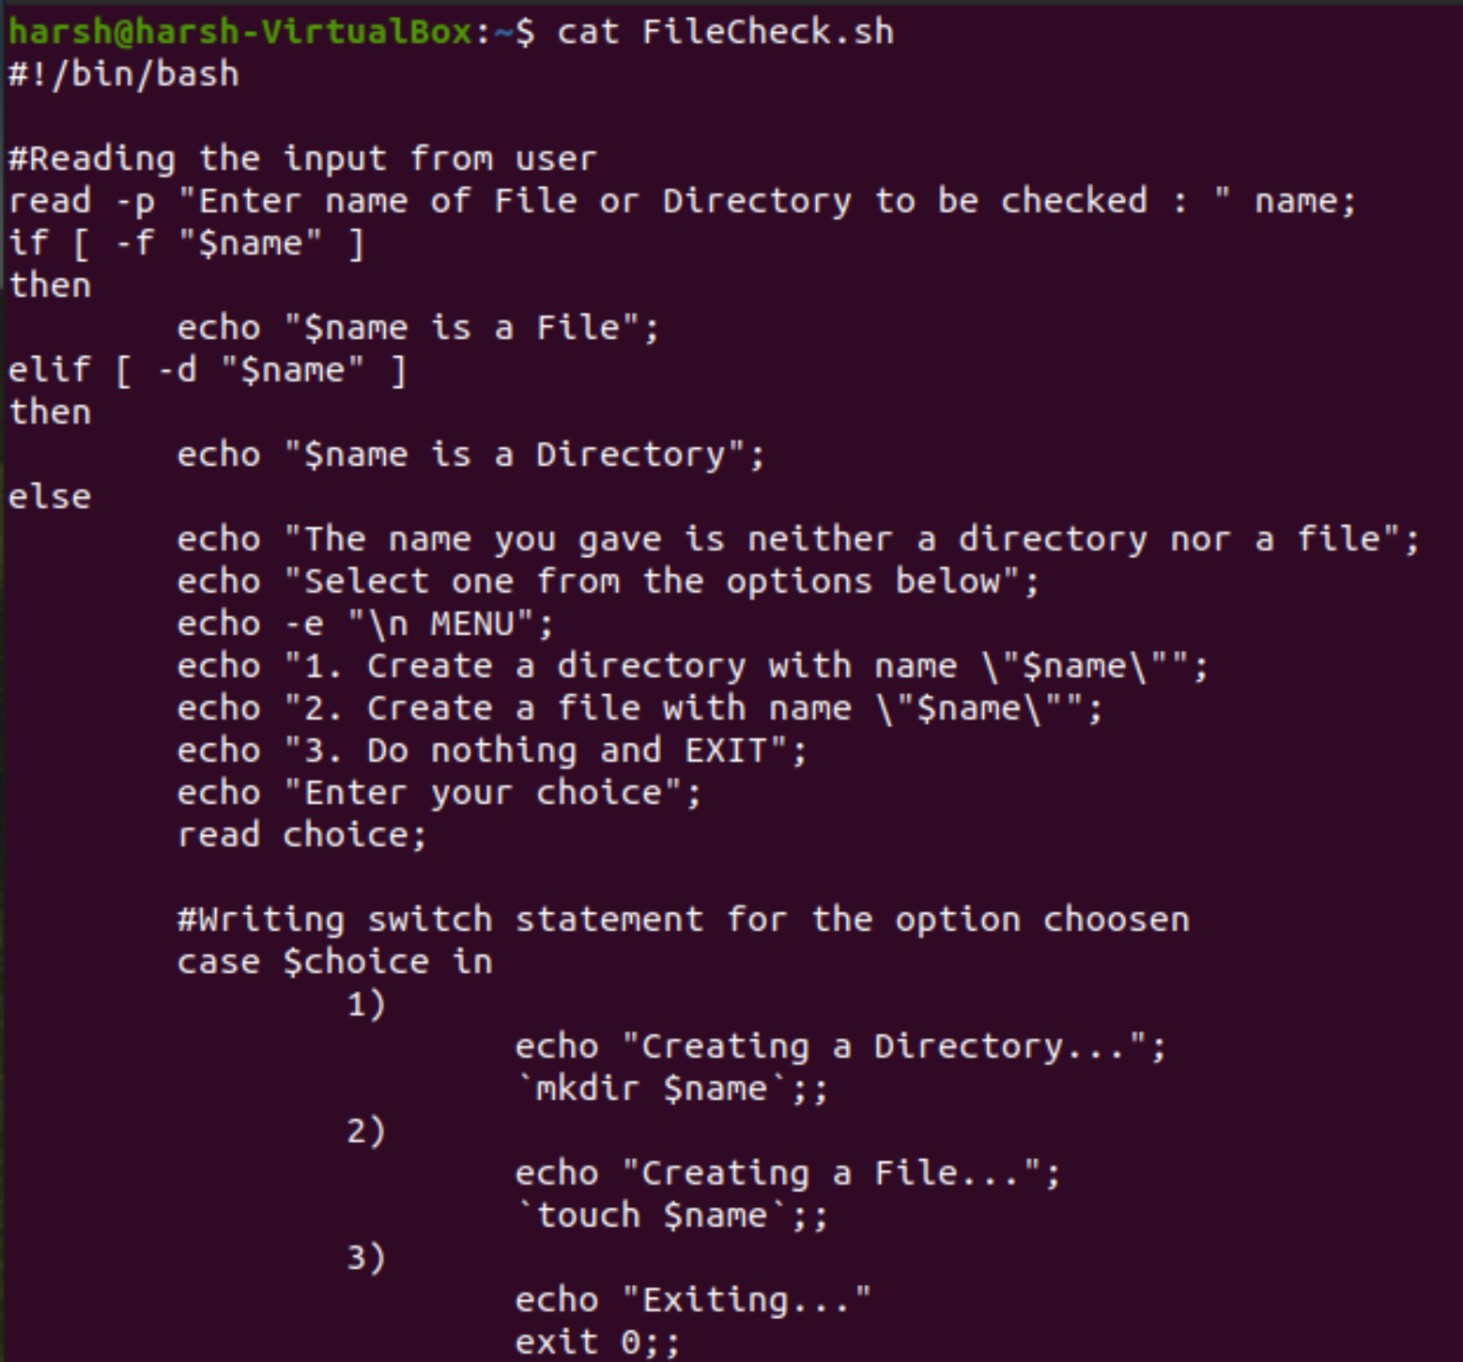

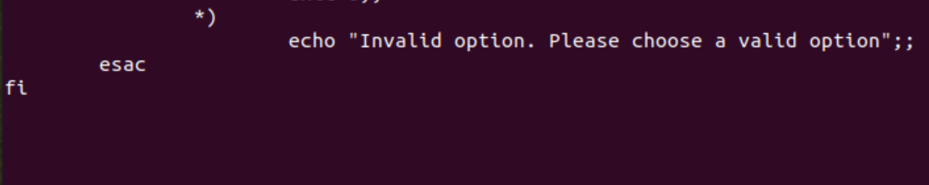

**OUTPUT**

1. **Fully Functional**

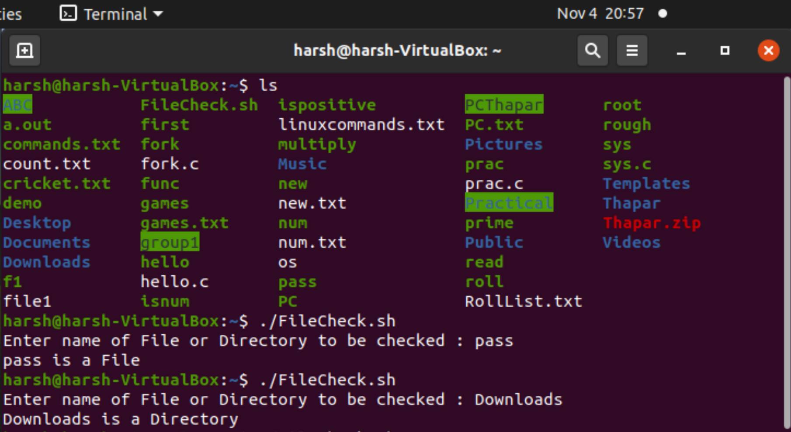

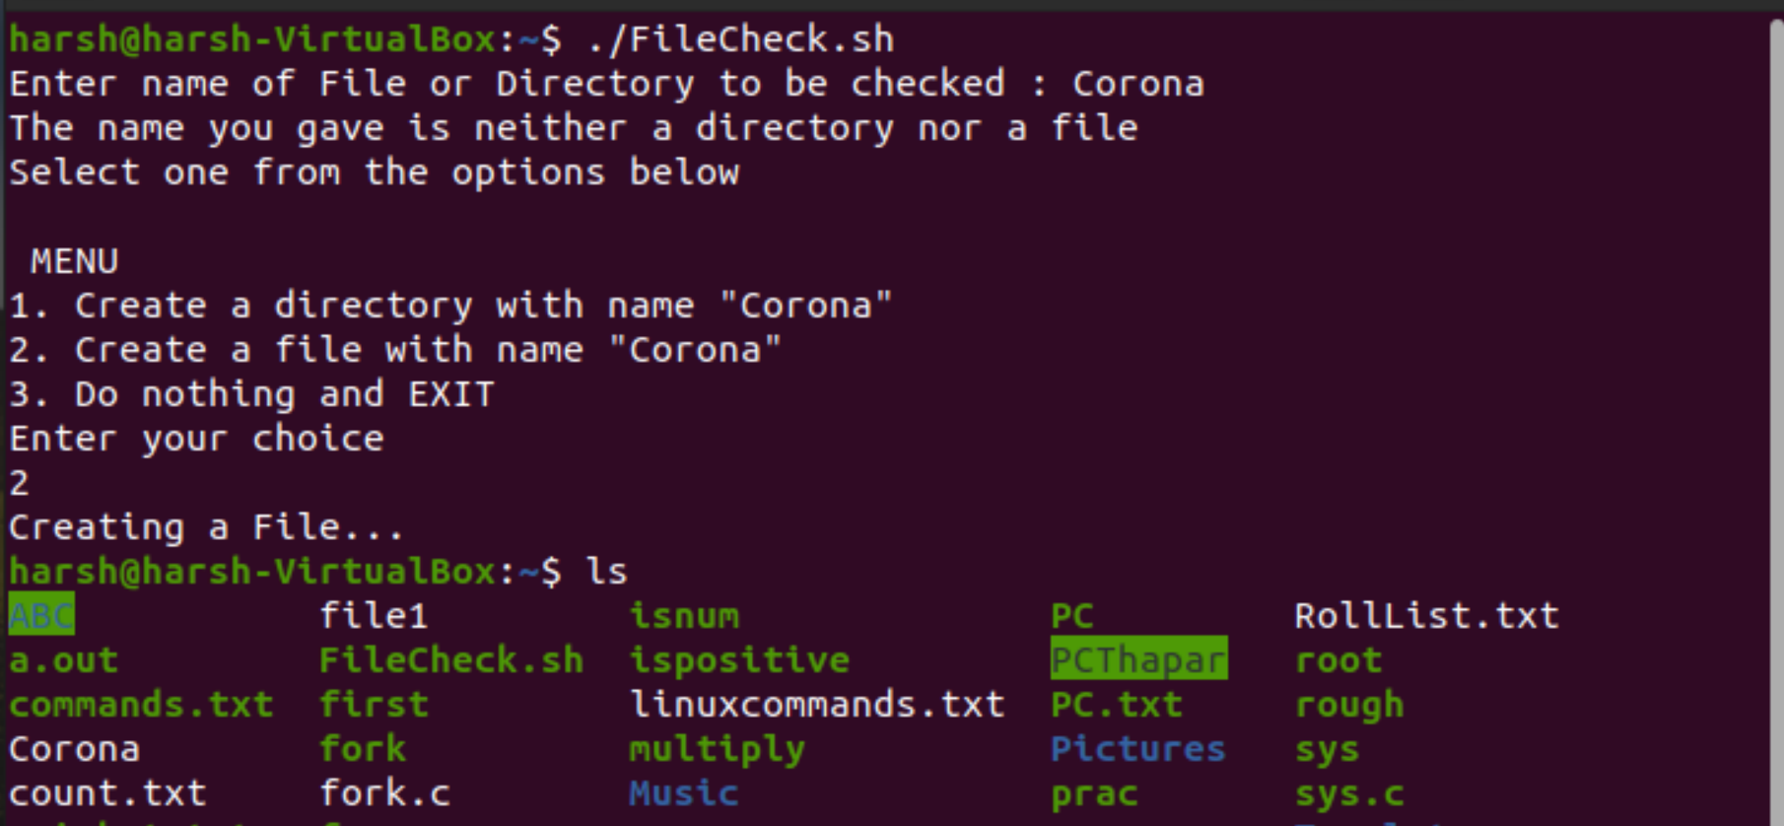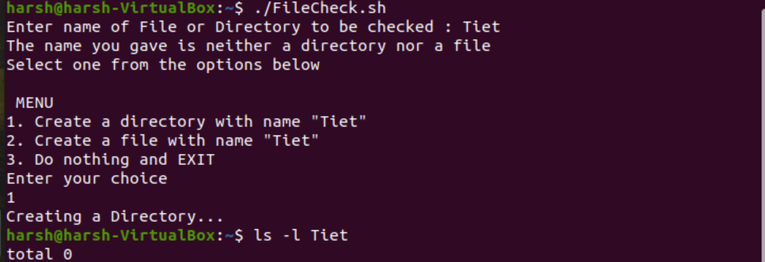

1. **Fault Tolerant**

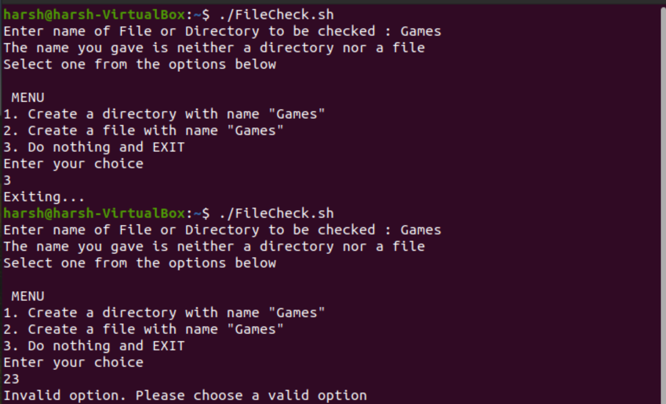

**__________________________________________**

**Question 4**

**Write a shell script for multiplying 2 matrices and printing the resultant matrix. Here you need to represent a 2-dimensional matrix using a 1-dimensional array**

**Solution -**

**Creating a Shell File for the Same and sharing the source code.**

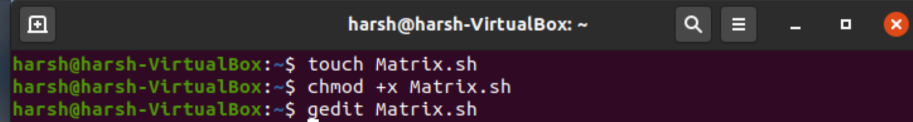

**SOURCE CODE**

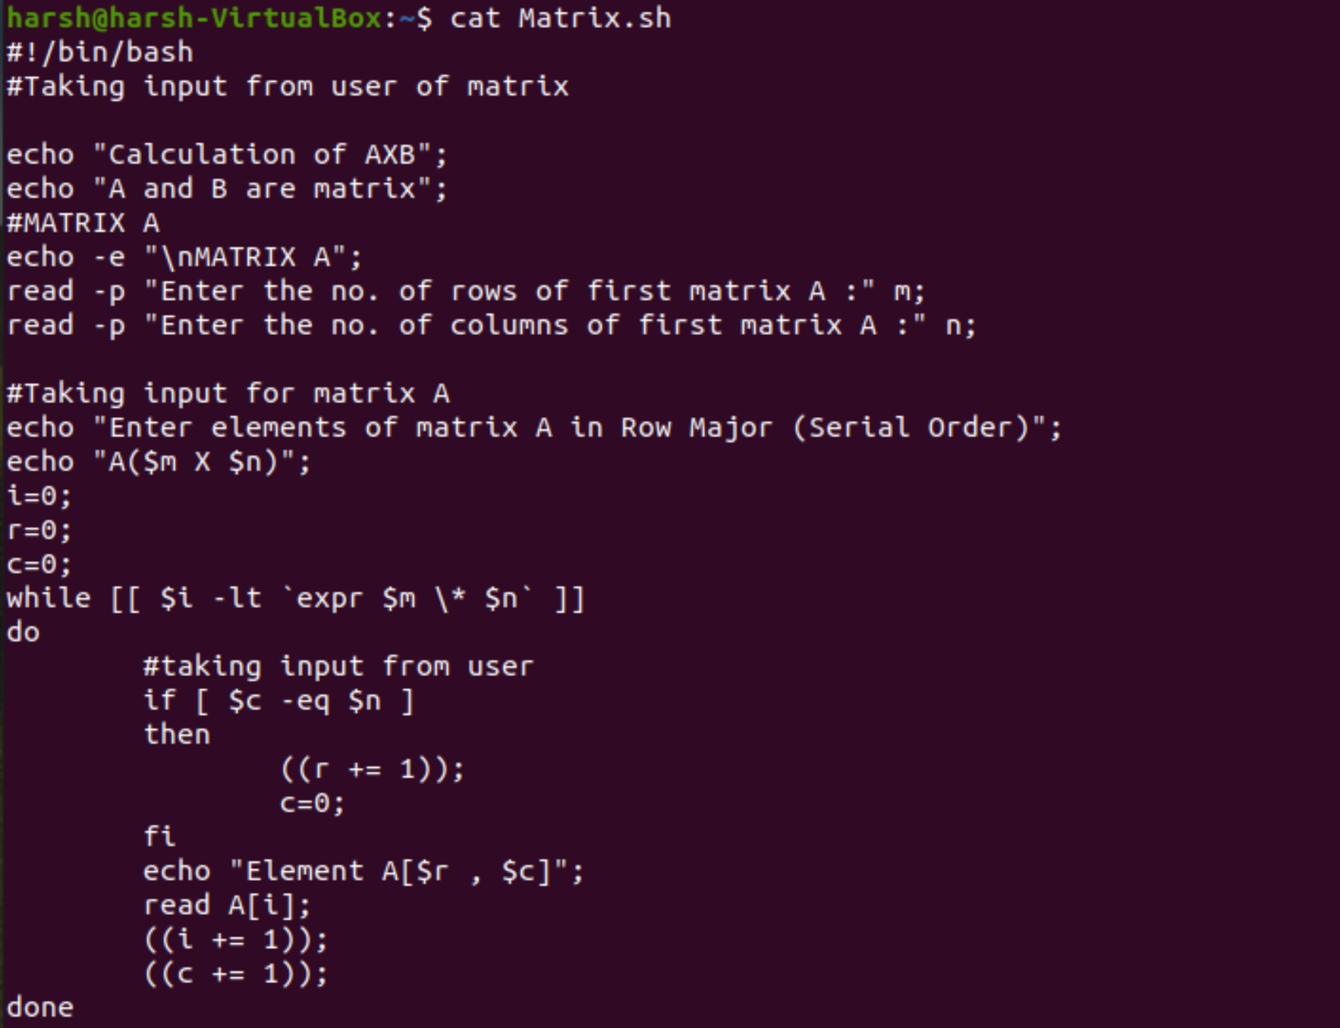

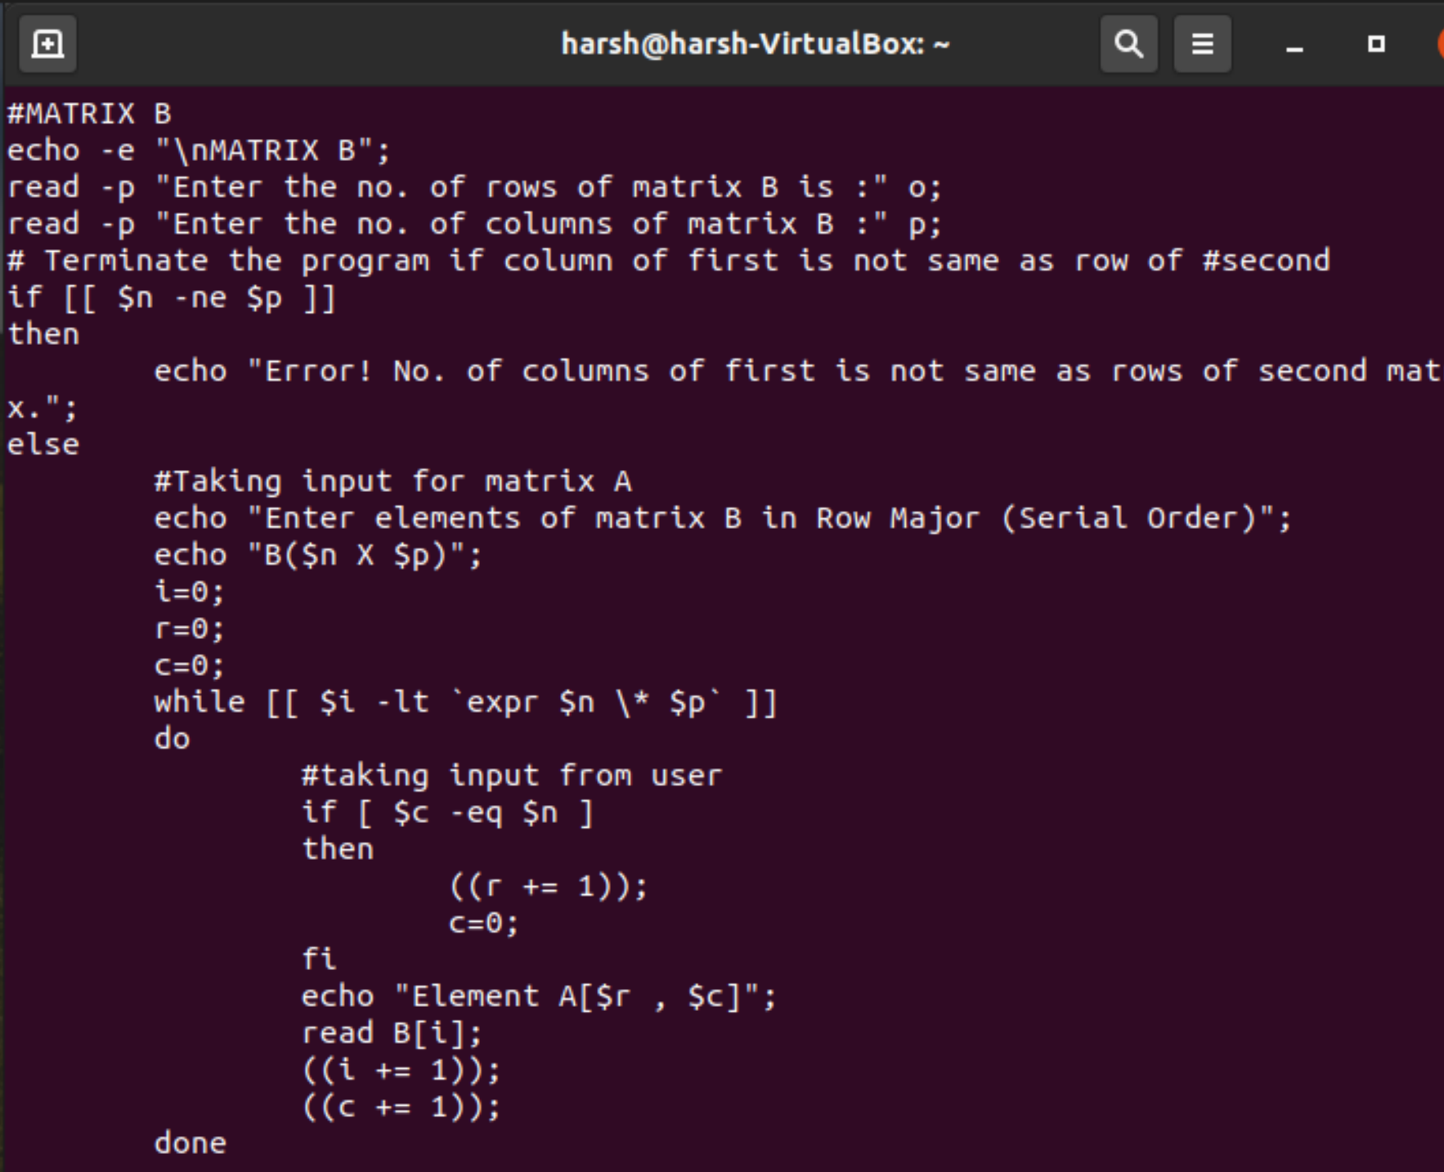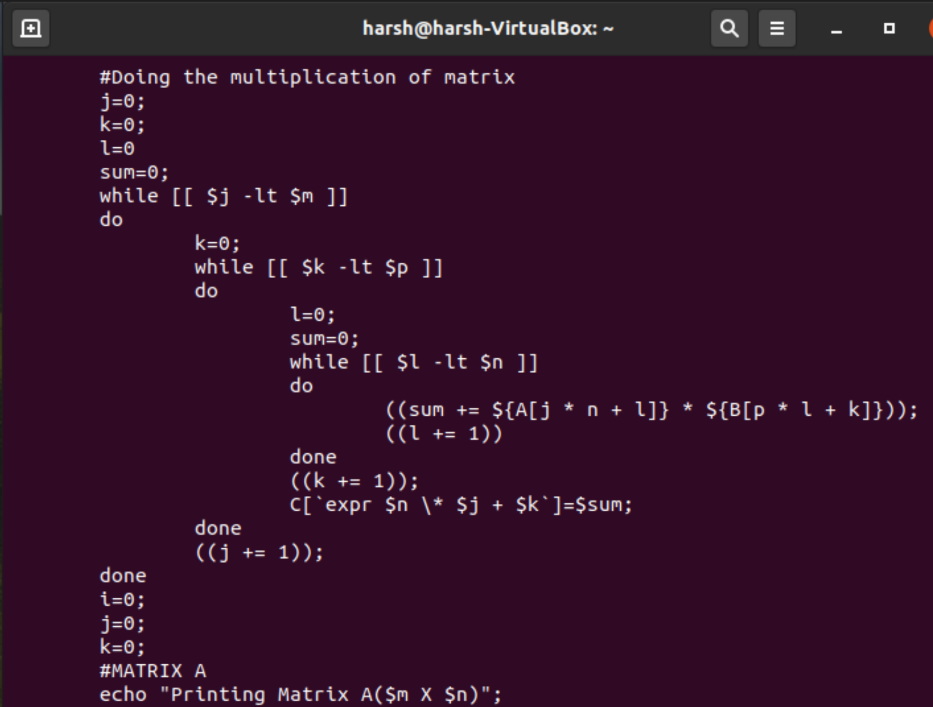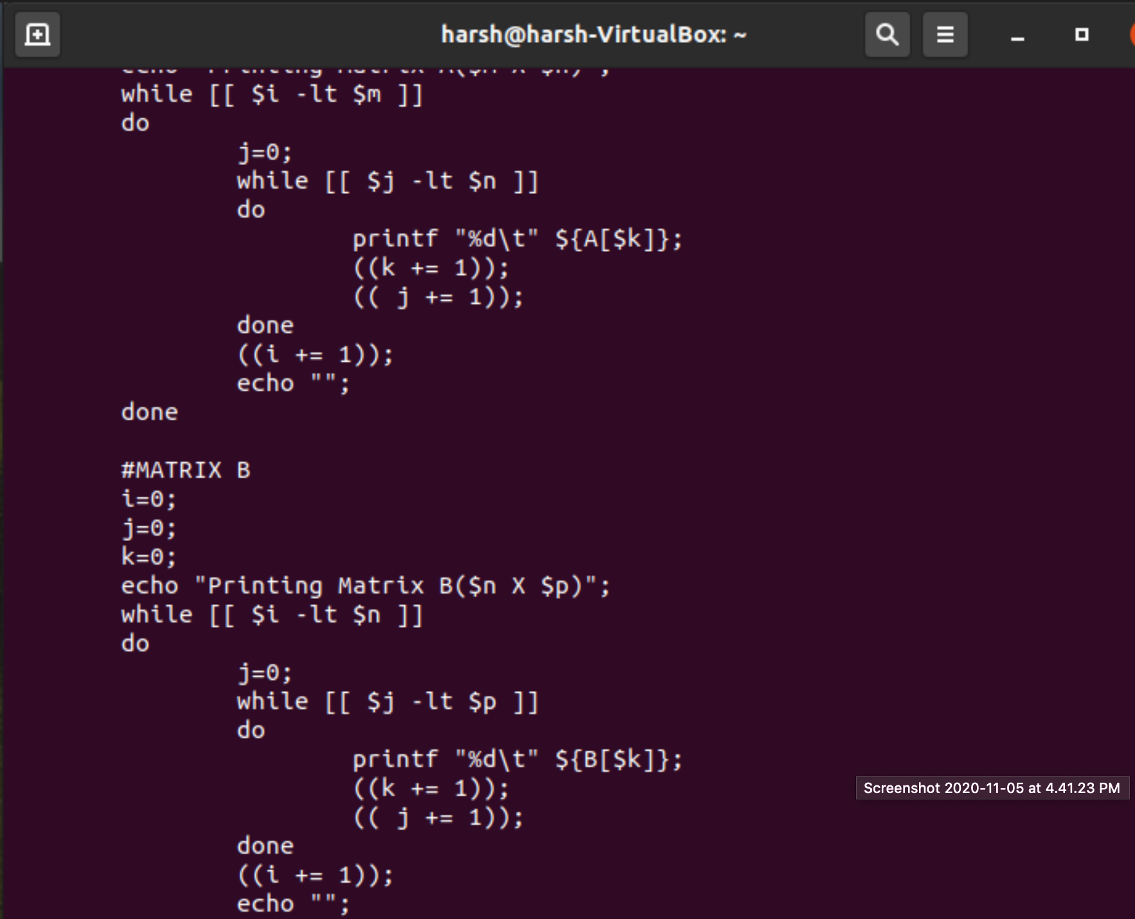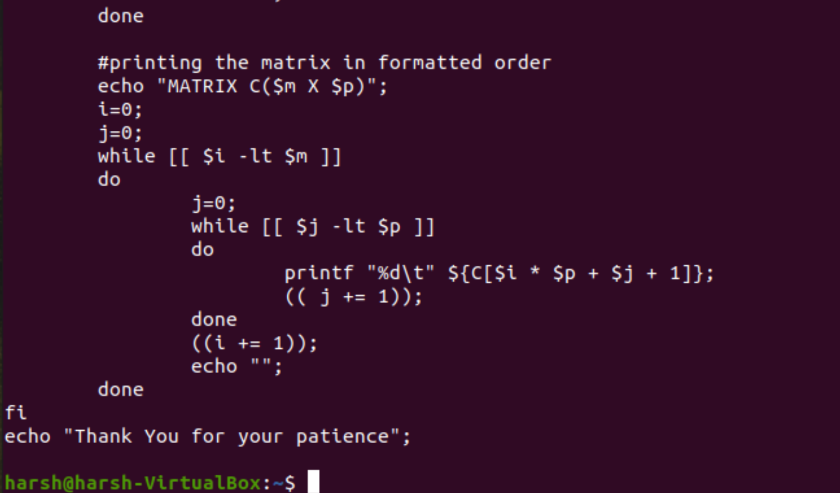

**OUTPUT**

1. **Fully Functional**

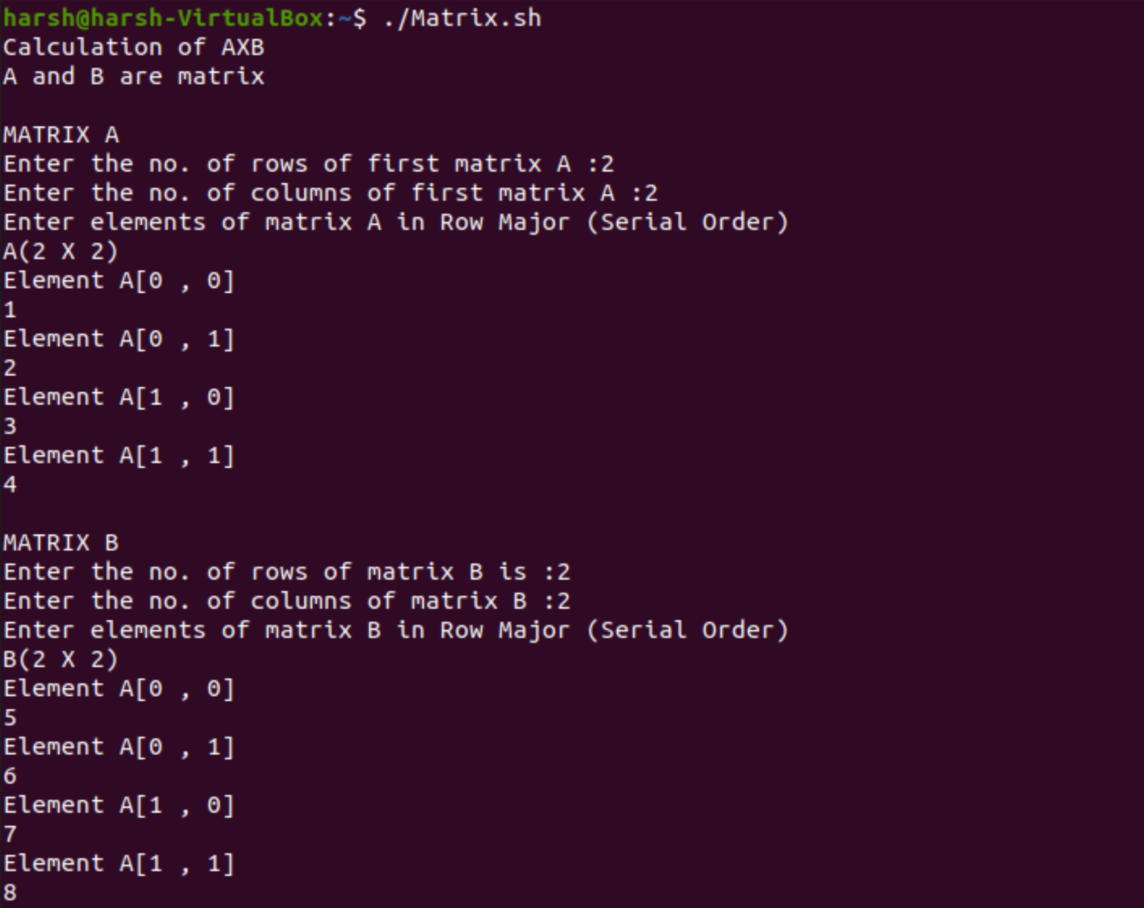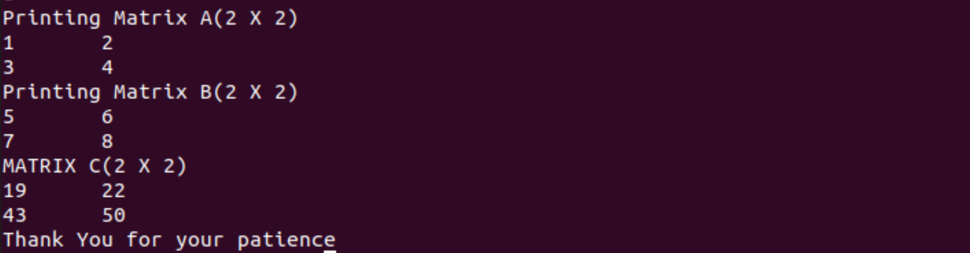

1. **Fault Tolerant**

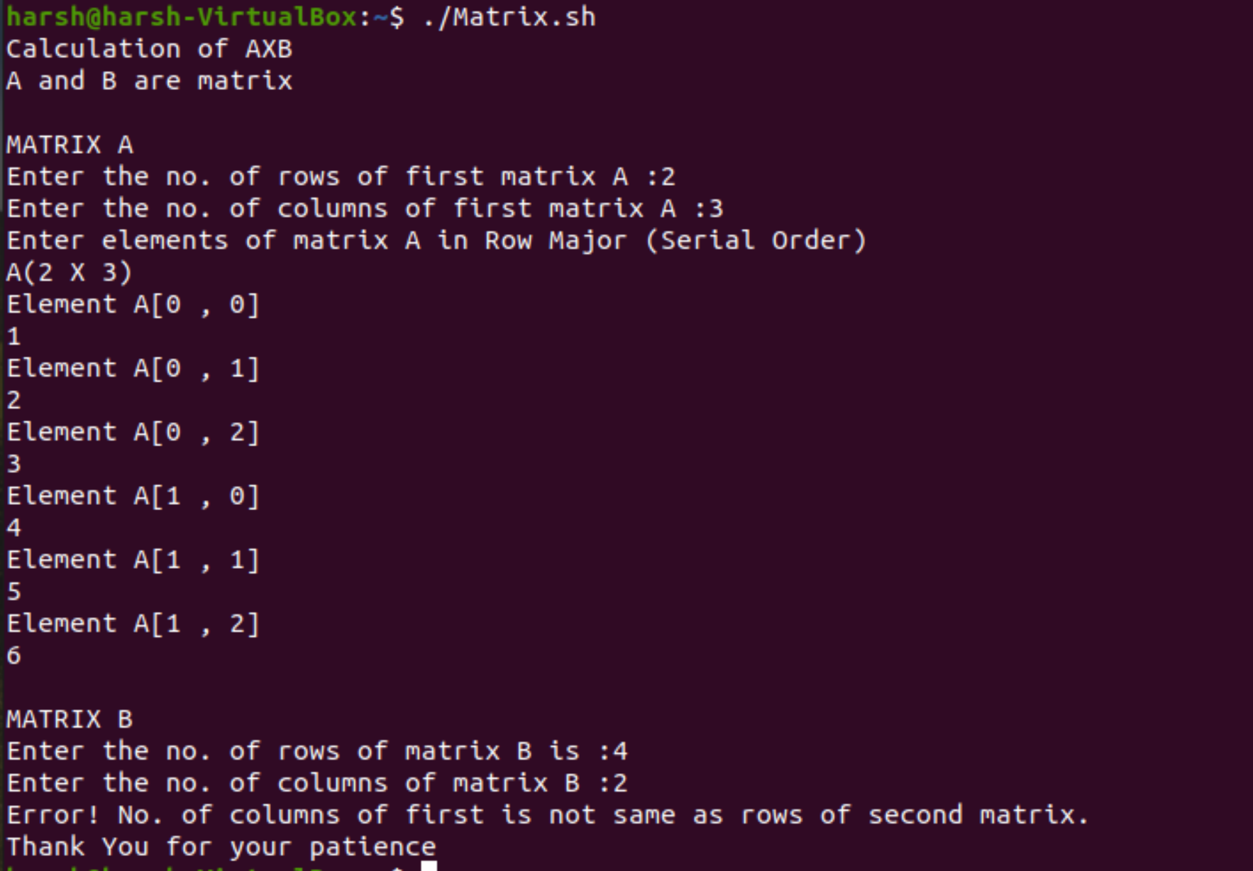

**__________________________________________**

**Question 5**

**Conversion:**

* **IPV4 to IPV6**
* **IPV6 to IPV4**

**Solution -**

***IPv4***

**IPv4 addresses are 32-bit numbers that are typically displayed in dotted decimal notation. A 32-bit address contains two primary parts: the network prefix and the host number. IPv4 is the most widely used version of the protocol despite the limitations of its 32-bit address space.**

**All hosts within a single network share the same network address. Each host also has an address that uniquely identifies it.**

**Depending on the scope of the network and the type of device, the address is either globally or locally unique. Devices that are visible to users outside the network (webservers, for example) must have a globally unique IP address. Devices that are visible only within the network must have locally unique IP addresses.**

**An IPv4 address is a series of four eight-bit binary numbers separated by a decimal point.** *Example*

*Site Dot-decimal Binary*

*Google.com 172.217.168.238 10101100.11011001.10101000.11101110*

***IPv6***

**Internet Protocol version 6 is the most recent version of the Internet Protocol, the communications protocol that provides an identification and location system for computers on networks and routes traffic across the Internet.**

***IPv4 to IPV6***

**In this method**

1. **Convert the Decimal IPv4 address in to Binary representation.**
2. **Divide this Binary representation into four groups.**
3. **Make sure each group have the 8 bit binary number.**
4. **Divide this binary number in two parts which is 4 bits**
5. **Convert this 4 bit into hexadecimal number representation.**
6. **We get hexadecimal number i.e. 8 hexadecimal number**
7. **Group in to two parts i.e. 4 hexadecimal in in one group which is 16 bit binary number in the one group in IPv6 address.**

**So we get two group out of 8 group of IPv6 address with the help of IPv4 address.**

Example:

We have IPv4 : 192.168.25.234

* Converting this IPv4 into Binary representation.

192 - 11000000

168 - 10101000

25 - 00011001

134 - 11101010

So, it is basically

192.168.25.234

11000000.10101000.00011001.11101010

* Dividing it into 4 groups

11000000 10101000 00011001 11101010

* Dividing this binary number in two parts which is 4 bits

1100 | 0000

1010 | 1000

0001 | 1001

1110 | 1010

* Converting this 4 bit into hexadecimal number representation

1100 - C 0000 - 0

1010 - A 1000 - 8

0001 - 1 1001 - 9

1110 - E 1010 - A

* Now, Grouping it back of 4 bit

C0A8 19EA

* Putting it together

IPv6 : C0A8:19EA

***IPv6 to IPV4***

**In this method , we will follow the reverse fashion**

1. **Convert the hexadecimal IPv6 address in to Binary representation.**
2. **Divide this Binary representation into two groups.**
3. **Make sure each group have the 16 bit binary number.**
4. **Divide each group in two parts each consisting of 8 bits**
5. **Convert this 8 bit into decimal number representation.**
6. **We get two decimal representation each from two group, four in total.**

Example

Taking the same IPv6 : C0A8:19EA

* Converting the hexadecimal IPv6 address in to Binary representation.

C - 1100

0 - 0000

A - 1010

8 - 1000

1 - 0010

9 - 1001

E - 1110

A - 1010

* Dividing this Binary representation into two groups.

COA8 19EA

1100 0000 1010 1000 0001 1001 1110 1010

* Dividing each group in two parts each consisting of 8 bits

1100 0000 | 1010 1000 0001 1001 | 1110 1010

* Converting this 8 bit into decimal number representation.

1100 0000 - 192

1010 1000 - 168

0001 1001 - 25

1110 1010 - 234

* Groupong it together.

1100 0000 | 1010 1000 0001 1001 | 1110 1010

192 168 25 234

* Seperate it with dot notation and we are done.

IPv4 : 192.168.25.234

**_________________________________________**

**Question 6**

**#!/bin/bash**

**Array= (Csed, Practical, Computing, UCS311,Tiet)**

1. **Write a command to display all elements except first one**
2. **what will be the output of**
   1. **echo ${arr[0]:1}**
   2. **echo ${array[@]:1:3}**
   3. **echo ${array[1]:5:5}**

**Solution -**

**We can use arrayin terminal.**

**Array=(Csed, Practical, Computing, UCS311, Tiet);**



**We will create an array as arr**

1. **To display all elements except first one, we will print following command**

**echo ${arr[@]:1};**

1. **Displaying Output**
   1. **echo ${arr[0]:1}**

**Output - sed,**

* 1. **echo ${array[@]:1:3}**

**Output - Practical, Computing, UCS311**

* 1. **echo ${array[1]:5:5}**

**Output - ical,**

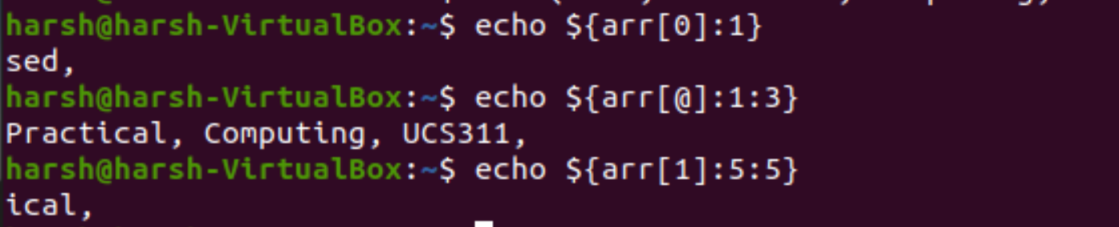

**_________________________________________**

**Thank you...**